Reading List for Sports Injuries ESO

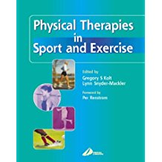
Title: Physical Therapies in Sport and Exercise
Editors: Gregory S Kolt, Lynn Snyder-Mackler
Publishers: Churchill Livingstone
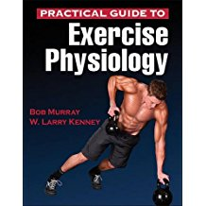
ISBN 0-443-07154-3
Title: Practical Guide To Exercise Physiology
Editors: Bob Murray, W. Larry Kenney
Publishers: Human Kinetics
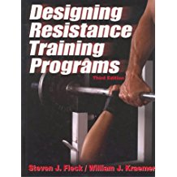
ISBN 978-1-4504-6180-1
Title: Designing Resistance Training Programs
Editors: Steven J. Fleck, William J. Fraemer
Publishers: Human Kinetics
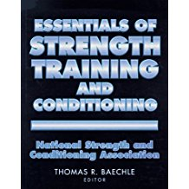
ISBN 0-87322-508-2
Title: Essentials Of Strength Training And Conditioning
Editors: Thomas R. Baechle
Publishers: Human Kinetics
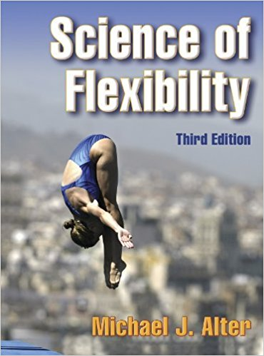
ISBN 0-87322-694-1
Title: Science Of Flexibility
Editors: Michael Alter
Publishers: Human Kinetics
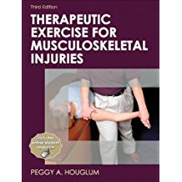
ISBN 0-87322-977-0
Title: Therapeutic Exercises For Musculoskeletal Injuries
Editors: Peggy A. Houglum
Publishers: Human Kinetics
ISBN 13: 978-0-7360-759-4
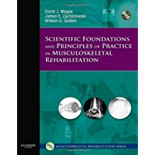
Title: Scientific Foundations and Principles of Practice in Musculoskeletal Rehabilitation
Editors: David J. Magee, James E. Zachazewski, William S. Quillen
Publishers: Saunders Elsever
ISBN 13-978-1-4160-0250-5

